**Book a Booth Content**

**We need to add the same template as this one for each booth booking:**

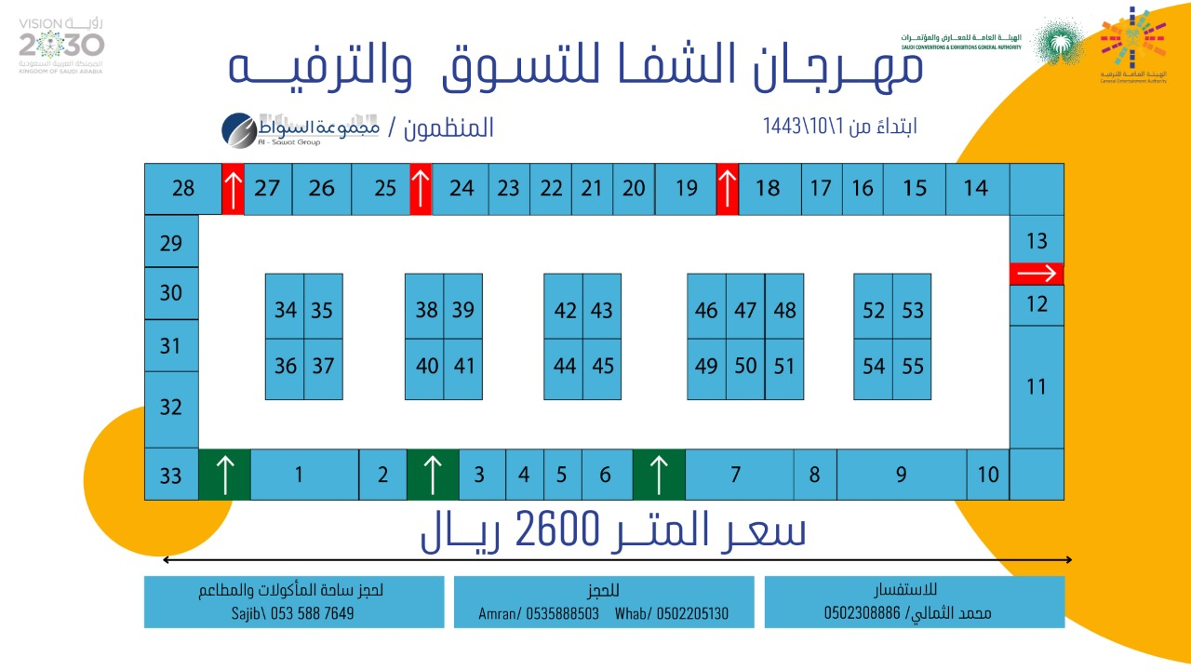

**It is like a draft or plan that shows chair and spaces numbers of a certain event, where each customer can book a number... So, we need to enable on the website showing the booked spaces in red and available spaces in green color**

**The main data will be as follows:**

|  |  |
| --- | --- |
| **English** | **Arabic** |
| **Event Name:**  **Al Shifa Shopping and Leisure Festival** | **مهرجان الشفا للتسوق والترفيه** |
| **Meter Price:**  **2600 Riyal** | **سعر المتر**  **2600 ريال** |
| **Starting date from:** | **إبتداءاً من** |

**It will be the same as booking hotel rooms, the booked rooms in red, and the available rooms in green**, **as the image below**

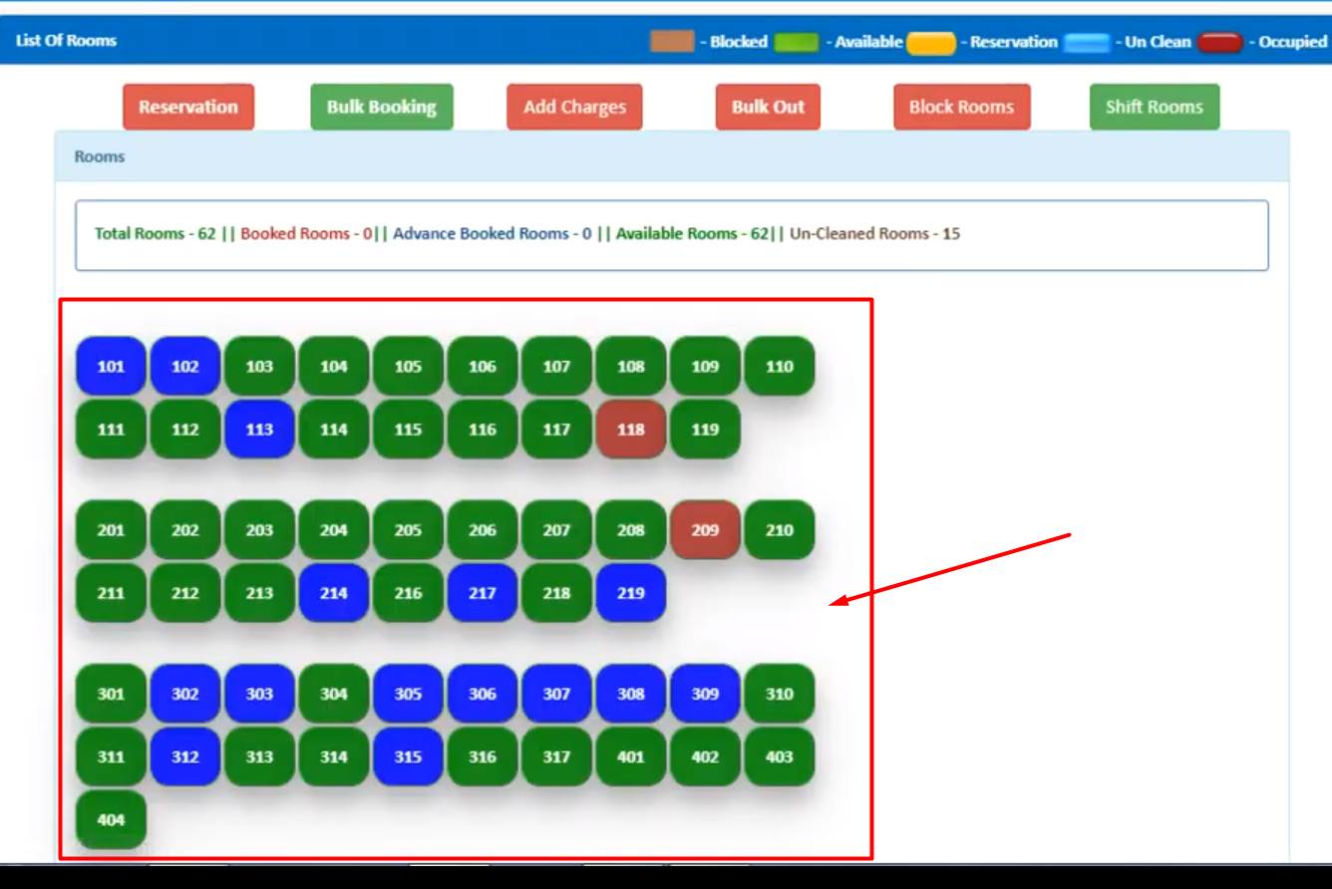

[**https://youtu.be/h72Oe3dmwvc**](https://youtu.be/h72Oe3dmwvc) **You can see this video to understand more**